MyTitle

* Before

1. Number1
2. Number2

helleWordAddRunHello

asdfasdfasdf工是柑茜

# MyHead1 Paragraph and Run

EmptyParagraph

West

Two**Next**

## Heading2

**MyContentabc** Main Main2 *Main3* Main3

Alignment1

Alignment2

Alignment3

### Image

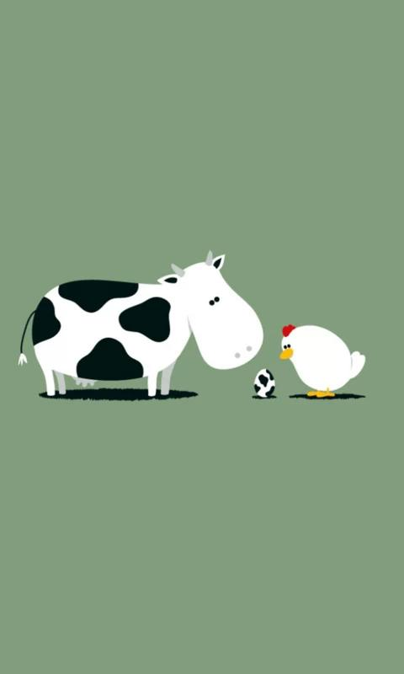



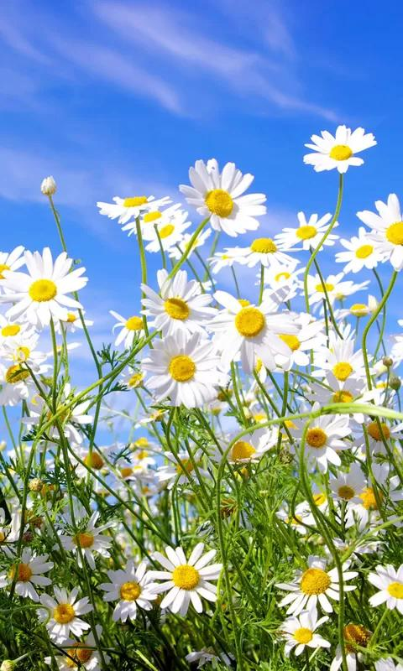



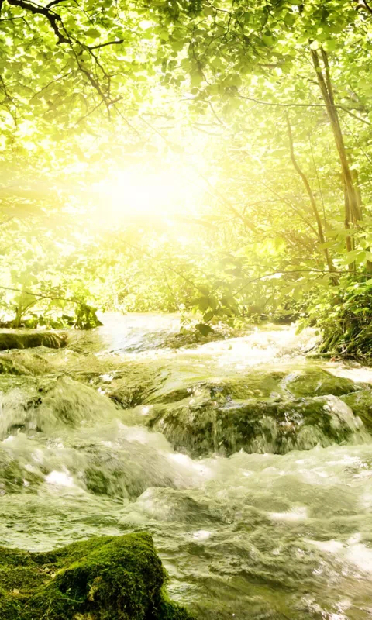



|  |  |  |  |
| --- | --- | --- | --- |
| Hello | Word | !!! |  |
| |  |  |  |  |  | | --- | --- | --- | --- | --- | |  |  |  |  |  | | Table!!! |  |  |  |  | |  |  |  |  |  | |  |  |  |  |  | |  |  |  |  |  | |  |  |  |
|  |  |  |  |
|  |  |  |  |

### Merge Table Cell

|  |  |  |  |  |  |
| --- | --- | --- | --- | --- | --- |
| Hello  Word    !!! | | |  | new Paragraph |  |
|  |  |
|  |  |
|  |  |  |  |  |
|  |  |  |  |  |  |

|  |  |  |
| --- | --- | --- |
| Hello |  | |
|  |
|  |
| Hello | | |
|  |  |  |
|  |  |  |

End